IAAP-Peninsula Chapter February Meeting

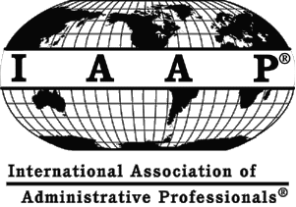
Debra Miller Lawhon, CMP
Director of Catering
Williamsburg Marriott
50 Kingsmill Road
Williamsburg, Virginia 23185
"MEETING PLANNING"

This is an overview of how to successfully plan meetings and events for social, corporate and association groups.

“I have worked in the hotel industry for 30 years. Hopefully, you will be able to learn a few planning tips that can be used in your personal or professional lives.” Debra


DATE: February 21, 2012

TIMES:
5:30 p.m. - Networking
6:00 p.m. – Program
7:00 p.m. – Business Mtg

LOCATION:
SMOKE BBQ Restaurant & Bar
10900 Warwick Blvd.
Newport News, VA 23601

CHAPTER OFFICERS:
JoAnn Panuska, President
Beverly Ware, CAP-OM, VP
Tyronda Womack, Treasurer
Mary-Ann Grocki, Secretary

CHAPTER WEBSITE:
www.iaap-peninsula.org

